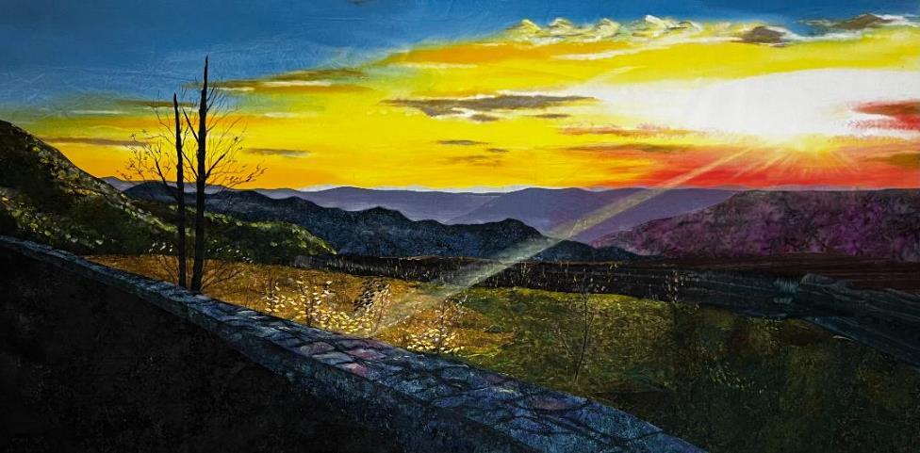
Painting a Quilt-able Sky
“And The Heavens Kissed Shenandoah Goodnight” 2023

Following are the materials Nancy uses for her technique.
Please note that you do NOT need the materials for the presentation.

Materials:
Inspiration photo
PFD Fabric
Acrylic Paints – Artistic Artifacts Opaque and Semi-Transparent Textile Paints
OR Pro-Chem Opaque and Semi-Transparent Textile Paints
Brushes – various sizes: 1 inch, 2 inch and 3 inch painters’ brushes (or your preferred brushes)
Brushes – various sizes fine art brushes for detail work
GAC 100 – Acrylic Primer and Extender. Must be ordered online.
Empty yogurt containers for mixing paints, any size will do.
Water for rinsing brushes
Plastic drop cloth
Optional:
Shiva Oil Paintstiks
Richeson brushes for paintstiks
FYI, Artistic Artifacts brand textile paints, available at www.ArtisticArtifacts.com, are made by Pro-Chem. Pro-Chem’s paints are virtually the same and cost a little less. Order whichever suits your budget.
*IMPORTANT: You can layer oil paints over acrylics, but you cannot layer acrylics over oils. Take my word for it. I learned this the hard way.

